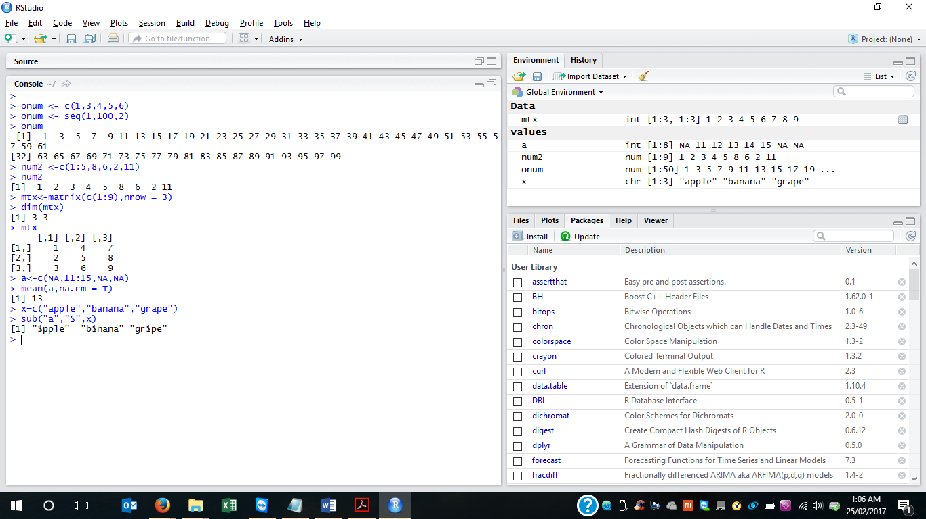

|  |
| --- |
| 1. Create a numerical vector to store the odd numbers between 1 to 100  >  > onum <- c(1,3,4,5,6)  > onum <- seq(1,100,2)  > onum  [1] 1 3 5 7 9 11 13 15 17 19 21 23 25 27 29 31 33 35 37 39 41 43 45 47 49 51 53 55 57 59 61  [32] 63 65 67 69 71 73 75 77 79 81 83 85 87 89 91 93 95 97 99  2. Create the numerical vector with following values  1,2,3,4,5,8,6,2,11  > num2 <-c(1:5,8,6,2,11)  > num2  [1] 1 2 3 4 5 8 6 2 11  • Create 3x3 matrix from the vector  > mtx<-matrix(c(1:9),nrow = 3)  > dim(mtx)  [1] 3 3  > mtx  [,1] [,2] [,3]  [1,] 1 4 7  [2,] 2 5 8  [3,] 3 6 9  3. Consider the following vector a<-c(NA,11:15,NA,NA) remove all the NA and find the mean of the vector  > a<-c(NA,11:15,NA,NA)  > mean(a,na.rm = T)  [1] 13  4. Consider the vector x=c(”apple”,”banana”,”grape”)  Replace the first occurrence of a with ‘$’  > x=c("apple","banana","grape")  > sub("a","$",x)  [1] "$pple" "b$nana" "gr$pe" |
|  |
| |  | | --- | | > | |